**COUNCIL ASSESSMENT REPORT**

|  |  |
| --- | --- |
| Panel Reference | PPSSNH-618 |
| MOD Number | MOD2025/0006 |
| LGA | City of Ryde |
| Proposed Development | Modification to Land and Environment Court Consent 2024/54712 (LDA2023/0320) to amend wording of conditions to allow for staged construction and the issuing of relevant Construction Certificates commensurate to the timing of the construction program for the approved co-living and student accommodation development |
| Street Address | 169-171 Herring Road, Macquarie Park  SP11415 and SP7929 |
| Applicant | Lei Lui – Freecity |
| Owner | Freecity Mac Park No.1 P/L |
| Date of DA lodgement | 5 February 2025 |
| Total number of unique submissions | No submissions received |
| Recommendation | Approval |
| Regionally Significant Development (Schedule 6 of the SEPP (Planning Systems) 2021) | A Section 4.56 modification application to a development with a capital investment value of more than $30 million. |
| List of all relevant s4.15(1)(a) matters | * Environmental Planning and Assessment Act 1979; * Environmental Planning and Assessment Regulation 2021. * State Environmental Planning Policy (Planning Systems) 2021; * State Environmental Planning Policy (Housing) 2021; * State Environmental Planning Policy (Biodiversity and Conservation) 2021; * State Environmental Planning Policy (Resilience and Hazards) 2021; * State Environmental Planning Policy (Transport and Infrastructure) 2021; * Ryde Local Environmental Plan 2014; and * City of Ryde Development Control Plan 2014. |
| List all documents submitted with this report for the Panel’s consideration | * Attachment 1: Recommended Conditions of Consent. * Attachment 2: L&E Court Judgement and Conditions of Consent (LDA2023/0320). |
| Clause 4.6 requests | N/A |
| Summary of key submission issues | No submissions received |
| Report prepared by | Shannon Butler – Senior Town Planner |
| Report date | 23 April 2025 |

|  |  |
| --- | --- |
| **Summary of s4.15 matters**  Have all recommendations in relation to relevant s4.15 matters been summarised in the Executive Summary of the Assessment report? | Yes |
| **Legislative clauses requiring consent authority satisfaction**  Have relevant clauses in all applicable environmental planning instruments where the consent authority must be satisfied about a particular matter been listed, and relevant recommendations summarized, in the Executive Summary of the assessment report? | Yes |
| **Clause 4.6 Exceptions to development standards**  If a written request for a contravention to a development standard (clause 4.6 of the LEP) has been received, has it been attached to the assessment report? | Not applicable |
| **Special Infrastructure Contributions**  Does the DA require Special Infrastructure Contributions conditions (S7.24)? | Not applicable |
| **Conditions**  Have draft conditions been provided to the applicant for comment? | Yes – No objection raised to amended conditions. |

1. **EXECUTIVE SUMMARY**

This Section 4.56 Modification Application is referred to the Sydney North Planning Panel ('SNPP') for determination as required by the *Sydney District & Regional Planning Panels Operational Procedures November 2022 (Operational Procedures Manuel)*. The Parent LDA2023/0320 is regionally significant development (over $30m) and this modification application is submitted under Section 4.56 of the Act.

The application is subsequent to the approved Local Development Consent No. LDA2023/0320 granted by the NSW Land and Environment Court for (as amended) for the demolition of existing buildings and construction of a 19 storey co-living and student accommodation development, comprising 507 rooms with two basement levels and associated landscaping works.

This is a Section 4.56 modification application to LDA2023/0320 seeking minor wording amendments to specific conditions of consent, enabling the staging of Construction Certificates. The intent of the staging is to allow the initial works to commence as early as possible, whilst allowing for the design to develop and additional information required by the conditions of consent to be prepared concurrently during construction.

Given the nature of the proposal, it was deemed that notification of the application was not required, hence no submissions were received.

It may be noted that there is a separate Section 4.56 application (PPSSNH-581 and MOD2025/0005) under assessment seeking a number of internal and external design changes to the approved development. This Section 4.56 application will be reported to the Panel for determination imminently.

The application is recommended for approval subject to the amended conditions of consent in **Attachment 1.**

1. **THIS PROPOSAL**

The proposal involves the modification of development consent No. LDA2023/0320 granted on 22 January 2025 by the NSW Land and Environment Court for the demolition of existing structures and construction of a 19 storey co-living and student accommodation development comprising 507 rooms with two basement levels and associated landscaping and works.

This is a Section 4.56 modification application to LDA2023/0320 seeking minor wording amendments to specific conditions of consent, enabling the staging of Construction Certificates through the consent.

The table below outlines the proposed staging in respect to obtaining Construction Certificates for the demolition and construction project. The intent of the below staging is to allow the initial works to commence as early as possible, whilst allowing for the design to develop and additional information required by the conditions of consent to be prepared concurrently during construction.

Each of the conditions proposed to be amended in the modification is proposed to be allocated to a particular Construction Certificate.

|  |  |
| --- | --- |
| **Construction Certificate** | **Details** |
| CC1 – Piling and Excavation | Completion of shoring piles, capping beam and bulk and detailed excavation in preparation for the concrete pouring. |
| CC2 – Inground services and structures | Completion of stormwater and OSD works and the pouring of concrete from the basement to ground floor slab and columns. |
| CC3 – Remaining general structure | Remaining structure to level 19 including modules. |
| CC4 – Fitout and façade | Balance of built form. |
| CC5 – External works and public domain | Balance of works external to the built form. |

1. **THE SITE**

The site is legally described as SP11415 and SP7929 and is known as 169 – 171 Herring Road, Macquarie Park. The Site is approximately 100m from Macquarie University Metro Station. The Site is located on the south eastern side of Herring Road and it is bounded by Herring Road to the northwest, 173 Herring Road to the northeast, Elouera Park to the southeast and 165-167 Herring Road and 25 Lachlan Avenue to the southwest.

The Site is regular in shape with a combined frontage of 49.71m to Herring Road, an average side boundary of 51.39m, a combined rear boundary of 50.24m and a combined total site area of 2568m². The Site has a fall of approximately 6.61m towards the southeast.

The Site is occupied by two separate allotments. Both lots are identical in their dimensions, facing Herring Road. Each lot previously contained residential flat buildings containing 15 units, however, these buildings have recently been demolished and excavation works are currently underway.

The site is zoned MU1 Mixed Use under the Ryde Local Environmental Plan 2014.

The Site is adjoined to the east by No. 173 Herring Road, which accommodates a four storey residential flat building.The Site is adjoined to the west by No. 165 - 167 Herring Road and 25 Lachlan Avenue.Both properties accommodate four story residential flat buildings.Directly opposite the Site, across Herring Road are older parts of Macquarie University andfurther to the west are high rise residential buildings of Macquarie Park.

Directly behind the Site is the Elouera Reserve which is a public recreation area. The surrounding development is predominately high density residential, educational and industrial/commercial land uses. The Site does not contain an item of heritage significance or located in the vicinity of a heritage item or within a heritage conservation area. Parts of Macquarie University are listed as items of local heritage significance.

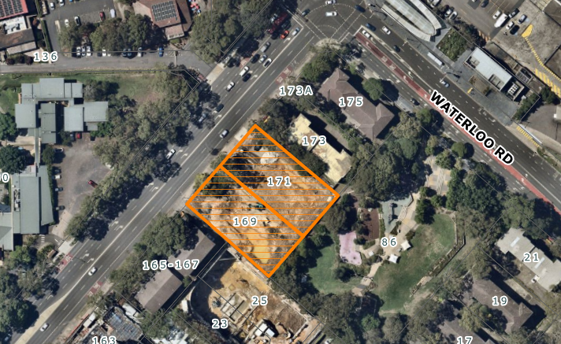

**Figure 1:** Aerial photograph of the site and locality.

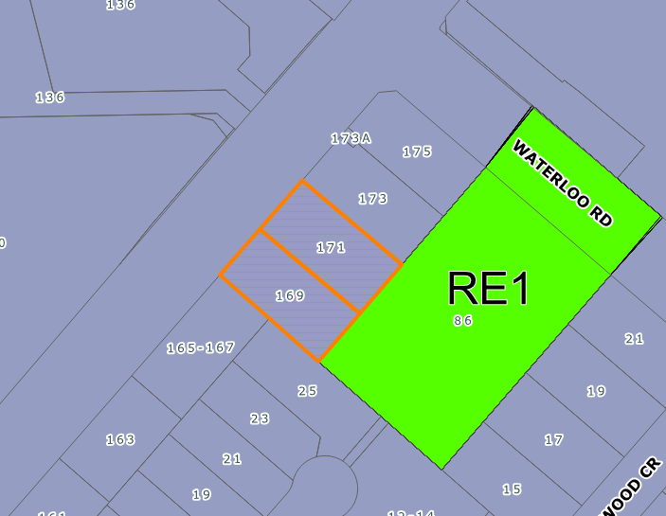

**Figure 2 -** Zoning map of surrounding area (purple represents MU1 Mixed Use and green represents RE1 Public Recreation)

1. **BACKGROUND**

Parent LDA2023/0320 was approved by the NSW Land and Environment Court on 22 January 2025 for the demolition of existing structures and construction of a 19 storey co-living and student accommodation development comprising 507 rooms with two basement levels and associated landscaping and works.

A separate Section 4.56 application (PPSSNH-581 & MOD2025/0005) was lodged on 5 February 2025 and is under assessment, seeking a number of internal and external design changes to the approved development. This Section 4.56 application will be reported to the Panel for determination imminently.

1. **STATUTORY PROVISIONS**

**5.1 Section 4.56 of the Environmental Planning and Assessment Act 1979 Modification of consents granted by the Court**

The proposal constitutes an amendment under Section 4.56 of the Act, the consent authority may consider an application to amend a development consent provided that:

*(1)(a) it is satisfied that the development to which the consent as modified relates is substantially the same development as the development for which the consent was originally granted and before that consent as originally granted was modified (if at all), and*

*(b) it has notified the application in accordance with:*

*(i) the regulations, if the regulations so require, and*

*(ii) a development control plan, if the consent authority is a council that has made a development control plan that requires the notification or advertising of applications for modification of a development consent, and*

*(c) it has notified, or made reasonable attempts to notify, each person who made a submission in respect of the relevant development application of the proposed modification by sending written notice to the last address known to the consent authority of the objector or other person, and*

*(d) it has considered any submissions made concerning the proposed modification within any period prescribed by the regulations or provided by the development control plan, as the case may be.*

*(1A) In determining an application for modification of a consent under this section, the consent authority must take into consideration such of the matters referred to in section 4.15(1) as are of relevance to the development the subject of the application. The consent authority must also take into consideration the reasons given by the consent authority for the grant of the consent that is sought to be modified.*

In *Tipalea Watson Pty Limited v Ku-ring-gai Council [2003] NSWLEC 253*, J Bignold came to deal with the matter of “substantially the same”, a list of matters or ‘tests’ to consider, being whether the modification involves the following:

*(a) significant change to the nature or the intensity of the use.*

*(b) significant change to the relationship to adjoining properties.*

*(c) adverse amenity impacts on neighbours from the changes.*

*(d) significant change to the streetscape.*

*(e) change to the scale or character of the development, or the character of the locality.*

Accordingly:

* The essence of the development as modified is substantially the same as the development for which consent was originally granted. The subject application seeks to amend the conditions of consent to permit multiple Construction Certificates for the development. The subject application has no implications on the originally approved building footprint or envelope or on the number of units within the development or on car parking.

Subsection (1)(b): Notification

The application was not required to be notified in accordance with Council’s Community Participation Plan as there are no physical changes to the development. It is concerned within conditions of consent only. As a result, there were no submissions received.

Subsection (1)(d): Submissions

No submissions were received in relation to the application.

Subsection (1A): Section 4.15(1) Considerations of Reasons for Granting of the Consent

The proposed modifications do not result in a development that is contrary to the reasons that informed the decision of the Court.

The proposed modification has been assessed against the relevant environmental planning instruments and policies and was found to be acceptable. This assessment report includes consideration of the relevant matters specified in Section 4.15 of the Act.

**4.2 Section 4.15 of the Environmental Planning and Assessment Act 1979**

When determining a development application, the consent authority must take into consideration the matters outlined in Section 4.15(1) of the Act.

**Environmental planning instruments (s4.15(1)(a)(i))**

The following Environmental Planning Instruments are relevant to this application:

* + 1. **State Environmental Planning Policy (Housing) 2021**

The original Development Application was assessed against the provisions of State Environmental Planning Policy (Housing) 2021. The subject application seeks to amend conditions of consent to permit the staging of Construction Certificates and does not result in any implications on compliance with the SEPP.

* + 1. **State Environmental Planning Policy (Biodiversity and Conservation) 2021**

The original Development Application was assessed against the provisions of State Environmental Planning Policy (Biodiversity) 2021. The subject application seeks to amend conditions of consent to permit the staging of Construction Certificates and does not result in any implications on the findings during the assessment of the original Development Application.

1. **4.2.3 State Environmental Planning Policy (Resilience and Hazards) 2021**

The original Development Application was assessed against the provisions of State Environmental Planning Policy (Resilience and Hazards) 2021. The subject application seeks to amend conditions of consent to permit the staging of Construction Certificates and does not result in any implications on the findings during the assessment of the original Development Application.

1. **4.2.4 State Environmental Planning Policy (Transport and Infrastructure) 2021**

The original Development Application was assessed against the provisions of State Environmental Planning Policy (Transport and Infrastructure) 2021. The subject application seeks to amend conditions of consent to permit the staging of Construction Certificates and does not result in any implications on the findings during the assessment of the original Development Application.

* 1. **Ryde Local Environmental Plan 2014**

The following is an assessment of the proposed development against the applicable provisions of Ryde Local Environmental Plan 2014 (Ryde LEP 2014).

**Clause 2.2 – Zoning**

The site is located within the MU1 - Mixed Use zone under the Ryde LEP 2014 and development for the purpose of co-living housing is permissible with consent in the zone. The subject modification application does not alter the permissibility of the development.

**Clause 2.3 - Zone Objectives**

The consent authority must have regard to the objectives for development in a zone when determining a development application in respect of land within the zone.

The objectives for the MU1 Mixed Use zone are as follows:

* *To encourage a diversity of business, retail, office and light industrial land uses that generate employment opportunities.*
* *To ensure that new development provides diverse and active street frontages to attract pedestrian traffic and to contribute to vibrant, diverse and functional streets and public spaces.*
* *To minimise conflict between land uses within this zone and land uses within adjoining zones.*
* *To encourage business, retail, community and other non-residential land uses on the ground floor of buildings.*
* *To ensure employment and educational activities within the Macquarie University campus are integrated with other businesses and activities.*
* *To promote strong links between Macquarie University and research institutions and businesses in the Macquarie Park corridor.*

The proposal seeks to modify the consent to introduce staging relating to Construction Certificates and does not alter the compliance of the development with the objectives of the zone.

**Clause 4.3 - Height of Buildings**

Clause 4.3 of Ryde LEP 2014 prescribes the maximum building height for the site as being 65 metres. In the original application a Clause 4.6 request was supported for a maximum height of 67.9 metres. The subject application does not seek to amend the originally approved building height.

**Clause 4.4 - Floor Space Ratio**

Clause 4.4 of RLEP 2014 prescribes the maximum floor space ratio for the site as being 4.95:1. The originally approved development had a floor space ratio of 4.93:1 and achieved compliance. The subject application does not seek to amend the originally approved floor space ratio.

**Ryde Development Control Plan 2014**

The original Development Application was considered against the relevant Parts of the Ryde Development Control Plan 2014 and was found to be satisfactory by the NSW Land and Environment Court. The subject application seeks to amend conditions of consent to permit staged Construction Certificates and does not result in any implications on compliance with the Ryde Development Control Plan 2014.

**Section 7.11 Contributions**

The application seeks to modify Condition No. 49 to allow for the payment of development contributions to deferred until prior to the issue of Construction Certificate No.3 – Remaining General Structure. This is considered to be consistent with the Ryde Section 7.11 Developer Contributions Plan 2020 which states the following under Section 6.1 – Timing of Payments:

*For development not involving subdivision, but where a construction certificate is required, the contribution must be paid prior to the release of the construction certificate for any works authorising construction above the floor level of the ground floor.*

The proposal has been discussed with Council’s Development Contributions Coordinator who raised no objection to the amendment of the condition to permit the full payment of the contributions prior to the issue of a Construction Certificate authorising any built form works above ground level given the above statement from the Contributions Plan.

1. **LIKELY IMPACTS OF THE DEVELOPMENT**

All relevant issues regarding environmental impacts of the proposed development are discussed throughout this report.

The modifications proposed by this application will not exacerbate any environmental impacts already approved under LDA2023/0320.

The development is considered satisfactory in terms of environmental impacts.

1. **SUITABILITY OF THE SITE**

The modification does not increase the scale of the development to what was originally approved and will not adversely impact upon the local road network.

As such, the site is considered to continue to be suitable for the development, as amended.

1. **REFERRALS**

The following section outlines the latest response from each of the internal and external referrals in relation to this application:

**Internal**

City Infrastructure (Public Domain)

The application was assessed by Council’s City Infrastructure (Public Domain) team and the following comment was received:

* *Conditions 68, 69, 70 and 71 of LDA2023/0320 for public domain works under Construction Certificate section are proposed to be located under CC5 – External Works and Public Domain stage.*

*Public Domain objects to the proposed modifications to Conditions 68, 69, 70 and 71 of LDA2023/320 for public domain works to suit staging of construction at CC5**stage for the following reasons:*

* *For CC3 stage, the applicant is proposing to construct the remaining 19 storeys with modules prior to constructing public domain works.*
* *Prior to building remaining 19 storeys, the internal driveway will need to be designed to ensure the final design levels ties in with vehicular crossing at road reserve at Herring Road for public domain works. The full extent of the driveway from Herring Road vehicular access to internal building will need to be designed in accordance with relevant Australian Standards.*
* *Public domain civil works design will not be complicated.*
* *Conditions 68-71 are considered to be more appropriately addressed prior to CC3 – Remaining General Structure.*

City Infrastructure (Waste)

The application was assessed by Council’s City Infrastructure (Waste) team and the following comment was received:

*All waste related conditions prior to Construction Certificate are acceptable to be amended to prior to proposed CC1 – Piling and Excavation as they relate to amended plans for proposed construction.*

City Infrastructure (Traffic)

The application was assessed by Council’s City Infrastructure (Traffic) team and the following comment was received:

*Among the list of Conditions for amendment, Condition 66 is related to traffic. The proposed amendments to the abovementioned condition are shown below with deletions indicated with a ~~strikethrough~~ and new wording in* ***bold****:*

*66. Construction Pedestrian and Traffic Management Plan. A Construction Pedestrian and Traffic Management Plan (CPTMP) shall be prepared by a suitably qualified traffic engineer and submitted to and approved by Council’s Traffic Services Department prior to issue of ~~any construction certificate~~* ***Construction Certificate CC1 - Piling and Excavation.***

*The proposed modification to Condition 66 aims at applying the requirement for CPTMP to the piling and excavation stage of the construction works only. However, other stages of the construction works still require management of pedestrian and traffic movements as a result of the construction works to ensure public safety and to minimise any impacts to the adjoining pedestrian and vehicular traffic systems. For this reason, it is recommended that Condition 66 be kept as it is.*

*Based on the above discussion, Traffic Services Department does not support the proposed modification of Condition 66.*

The remainder of the conditions sought to be amended are accepted, as detailed in the draft conditions at **Attachment 1**.

1. **PUBLIC NOTIFICATION & SUBMISSIONS**

As the proposal seeks to amend conditions of consent only, it was deemed that notification was not required in accordance with Council’s Community Participation Plan, therefore, no submissions were received.

1. **CONCLUSION**

The application has been assessed under the matters for consideration of Section 4.15 of the Environmental Planning and Assessment Act 1979 and the relevant statutory and policy provisions.

The proposal continues to be suitable for the site and is not contrary to the public interest.

Therefore, it is recommended that the application be approved for the following reasons:

* The modification satisfies the provisions of Section 4.56 of the Environmental Planning and Assessment Act 1979.
* The modification is substantially the same as the original approval.
* The development continues to be a permissible use, is consistent with the zone objectives and the height and floor space objectives under RLEP 2014.

1. **RECOMMENDATION**

That MOD2025/0006 to modify the consent for Local Development Application No. LDA2023/0320 on land at 169-171 Herring Road, Macquarie Park be approved subject to the amended conditions in **Attachment 1.**

**Report prepared by:**

**Shannon Butler**

**Senior Town Planner**

**Report approved by:**

**Holly Charalambous**

**Senior Coordinator Development Assessment**

**Sohail Faridy**

**Acting Manager Development Assessment**

**ATTACHMENTS**

Attachment 1: Recommended Conditions of Consent.

Attachment 2: L&E Court Judgement and Conditions of Consent (LDA2023/0320).